

Computer Games Development CW208

GDD

Year IV

Leo Chen

C00250594

24/04/2023

# 

# 

# 

[Declaration form to be attached]

**Acknowledgements 2**

**Game Overview 3**

**Feature Set 3**

General Features 3

Gameplay 3

The Game World 3

Inspiration 9

Additional Goals 11

References 12

# 

# **Acknowledgements**

We would like to thank the following people who assisted in completing this project including;

Lei Shi, my supervisor for giving me advice and insights on the project as a whole and my colleagues for their ideas, feedback and input as well as believing in me and my project.

# **Game Overview**

A Machine Learning Real Time Strategy game where the Machine Learning Agent/Opponent learns from every match you play. Both players must capture control points and generate scores from them for 5 minutes while simultaneously managing unit production and coordination.

The main objective of the game is a demonstration of the use of neural networks and machine learning agents as a viable opponent for human players. Unlike traditional real time strategy games with AIs developed to an exact skill level, the machine learning agent would scale based on your performance of the game.

# **Feature Set**

## **General Features**

2D Graphics

Real Time Strategy and unit controls

Basic economy system

Strategic capture points

## **Gameplay**

The main gameplay revolves around commanding groups of units to capture and hold strategic objectives.

Additionally, players are able to purchase units that spawn from their respective spawn points.

## **The Game World**

The game world is of a simplistic design in which there are 3 control points and 4 resource points for the players to capture. The world is in an enclosed area for which the boundaries of the game are set in.

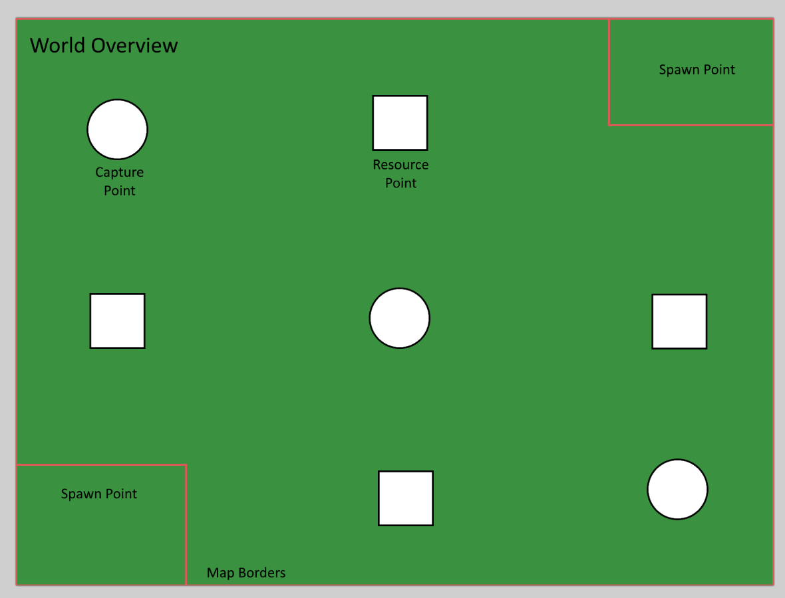

Fig.1 Mock up of environment

Main Gameplay Loop

The game revolves around holding capture points that generate a score for their respective team. Each game session lasts 3 to 5 minutes and whoever has the highest score once the timer ends would be considered the winner.

In these 3 to 5 minute games, the gameplay is short enough for the agent to have made enough decisions for use in evaluation.

Upon completion of a game, the agent is supposed to evaluate what strategies it employed had worked and which did not work in order to evolve for the next time it played.

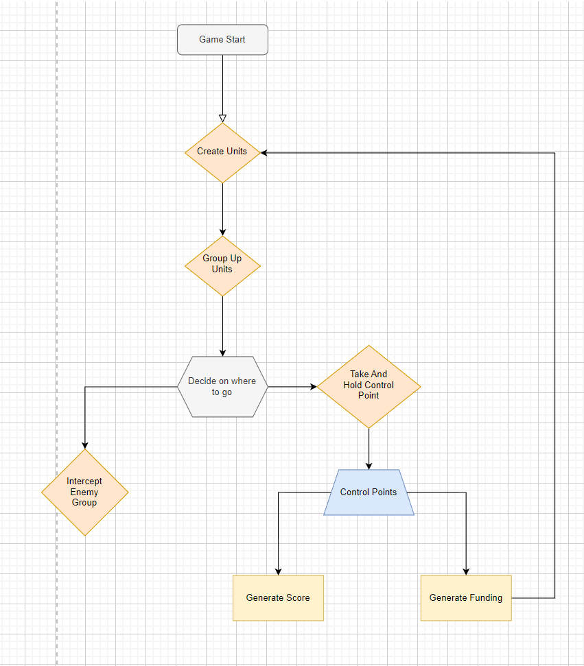

Fig.2 Basic Game Loop

Neural Networks and Unity’s Ml-Agents

Either through the use of a neural network with backpropagation or with Unity’s ML-Agent’s reinforced learning model, the agent is meant to adapt through two methods of reevaluation.

The first method is After Action Reevaluation. The traditional method in which it collects its actions completed and feeds it back through the neural network with the use of back propagation. The other more costly method to implement would be Real Time reevaluation. This proposed method would have the agent constantly reevaluate a decision it has made as well as react directly to the environment it is in.

Draft Neural Network Architecture

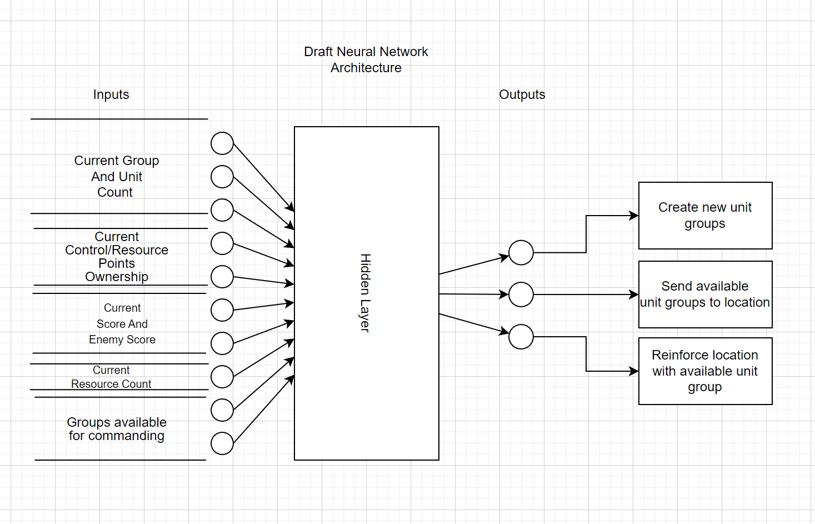

Fig.3 Proposed neural network architecture

Units and their behaviours

The units are meant to be programmed with two simple behaviours. To scan for targets to shoot at or to move to a location. Their field of view requires it so that they have a clear line of sight towards their target in order to fire.

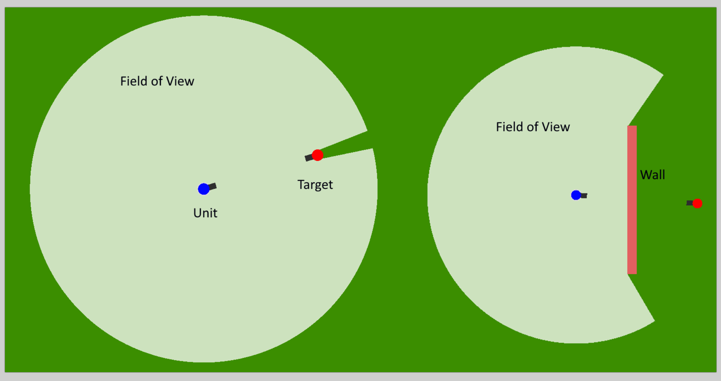

The simplistic behaviour will be the basis of the units the players can command. Without needing to over complicate their design. Though lessons will be taken from Artificial Intelligence in Video Games[(Millington 2019)](https://paperpile.com/c/4M2OP9/SMcw) in designing simple but effective unit AI.

**Formations**

Part of the unit design was to allow for the creation of formations. These allow for a tactical advantage when sending groups of units to battle where said formation is needed.

**Line Formation:**

A simple line formation that provides the best frontal fire power.

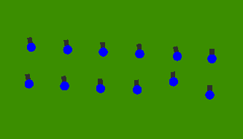

**Box Formation:**

A hollow formation that provides the best defensive advantage.

**Chevron Formation:**

An arrow head like formation which provides a wide arc of fire.

Control Points and Resource Points

The two main points of contention outlined in the introduction are control points and resource points.

**Control Points**

There are areas in which once captured will generate a score for their respective team.

Identified on the map as a circle, they will be the main areas of contention for them

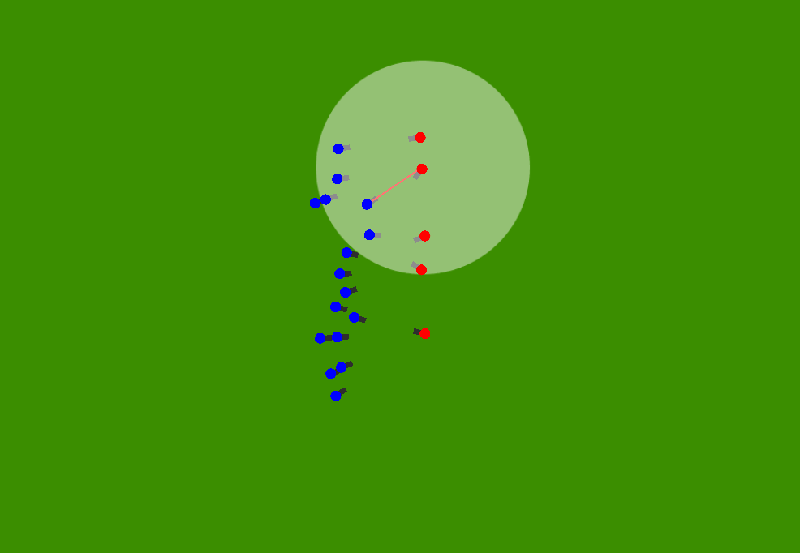

Fig4. Red and blue team contesting a control point

**Resource Points**

There are areas in which once captured will generate funding for their respective team. Secondary to the main control points but they allow for the generation of additional funding. This allows for more unit production. They are identified on the map as small squares.

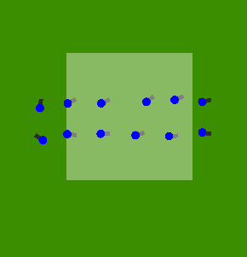

Fig.5 Blue team holding a resource point

To capture any point requires at least one unit to enter their area and to hold it for a certain amount of time until it is fully captured to your team’s side. Once done it will passively generate the points to the team’s side.

# Inspiration

Command and Conquer

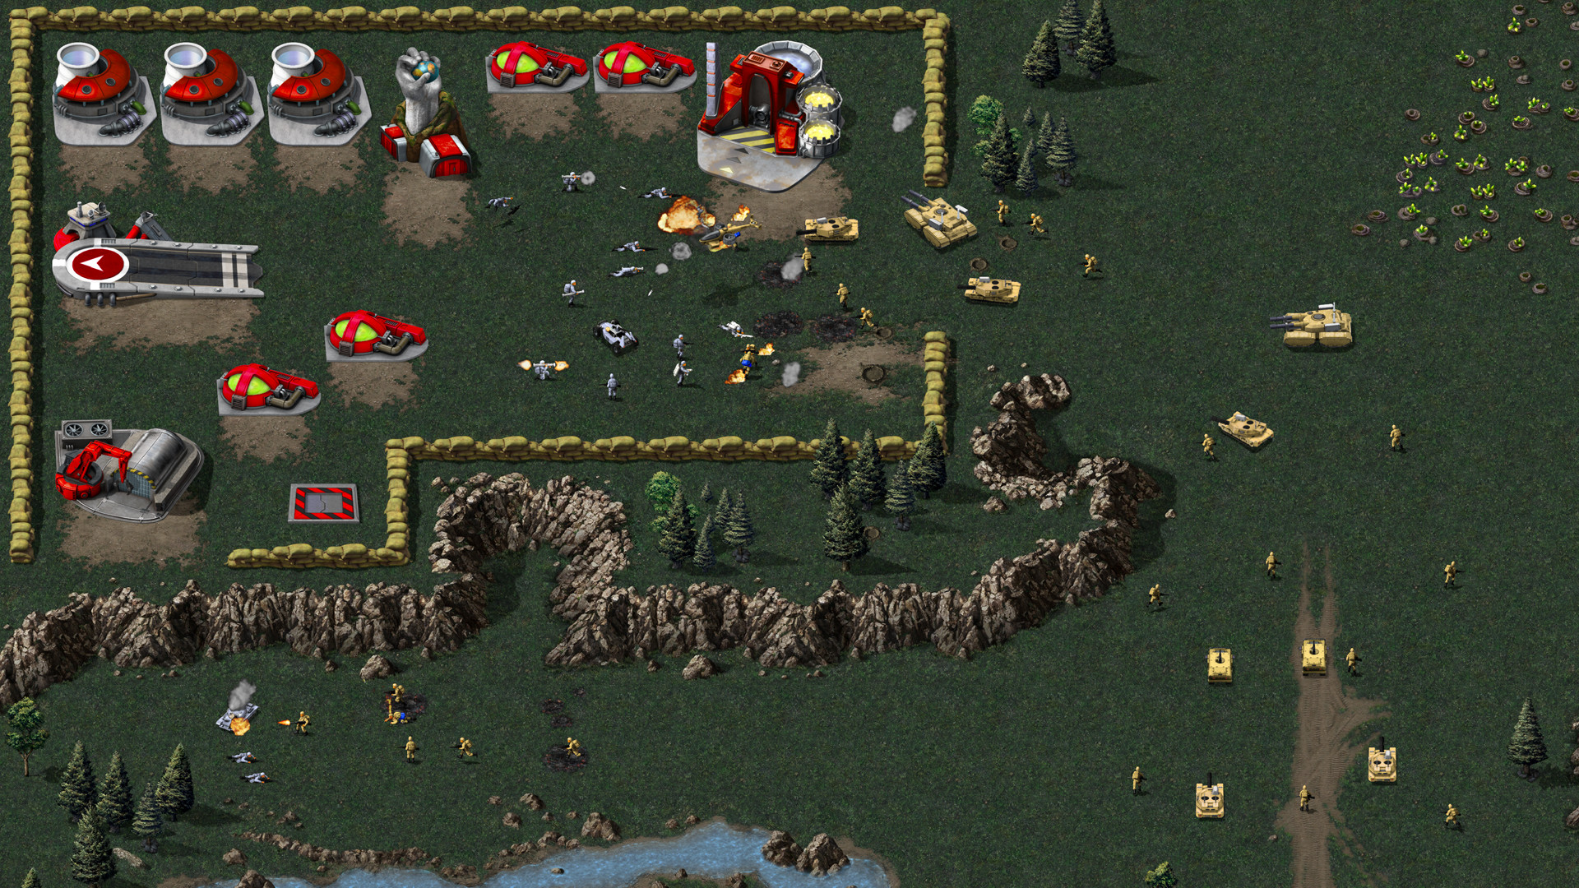

The father of all real time strategy games. The complex nature of the game with unit, economy and strategy management was a heavy inspiration for the project.

The gameplay, while more advanced than this project, takes some of its mechanical elements from the game.

Though the art style for my project is made up of very simplistic shapes, the underlying mechanisms that make up the game are somewhat present.

## 

## 

## Additional Goals

**Additional Units**

For additional content I would like to put in would be vehicles for the players to utilise. Two come to mind, tanks and jeeps.

Both of which would have their advantages and disadvantages to their use.

Tanks being the power but cumbersome and expensive unit.

And jeeps being fast but relatively weak units for hit and run action.

**Base Building**

Instead of having units spawned from one set location, I’d have it evolve into a more traditional RTS with buildings that produce those units. Worker units to fill the traditional construction of production buildings and with the potential of constructing defensive structures.

## References

Books:

Ian Millington, J. F., 2019. *Artificial Intelligence for Games.* s.l.:s.n.